**HTML5 Geolocation (module 11)**

1. Create a contact us form. Embed a map with your form and display location of your organization on map as shown below:

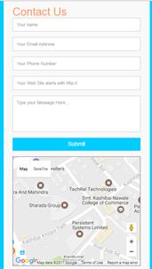

1. Display a map with satellite view for location (Persistent Systems Limited,9A/12, Erandwane, Pune). Keep zoom level of map to 8. Add a marker to the location and when user clicks on that marker an info window appears as shown below:

